Using the static housing system

So you want to buy a house. The Distro static housing system allows the shard developer, or a GM, to initialize, or setup static structures in advance for purchase by players with no staff intervention required during game play. All the player needs is enough gold in either their backpack or their bank box.

Looking for the right house.
This section assumes that the static structures available for sale have been initialized and have a For Sale sign posted.

As you mosey around the world and you come across a vacant house, by single click on the sign to see how much gold it will cost and the amount of lock downs and secures that are available for the house.
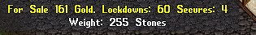

This is an example of what you might see by single-clicking on a house sign

Once you have found your dream house, simply double-click on the sign and you will receive a Graphical User Menu Pop-up (GUMP) asking you if you want to buy this house.
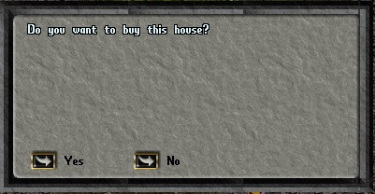

You decide this house is perfect and you click “Yes” on the GUMP. The system will first check your backpack for the amount of gold required to buy the house. If the required amount of gold is not in your backpack, the system will check your bank box for the gold. If it is not there you will receive a System Message informing you that you do not have enough gold to buy the house. The system does not combine your backpack and bank gold together. You must have the purchase amount either in your backpack or your bank box.

After the system finds the correct amount, either in your backpack or bank box it will extract the gold. You will receive two System Messages, one congratulating you and the other informing you that you have taken ownership of the house. Then a GUMP will appear informing you that a key has been placed in your backpack and a spare key and the deed have been placed in your bank box.
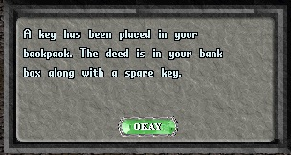

Now that you have your dream house, I will cover some key things to help you.

The system will have locked the exterior doors to your home. The key in your backpack allows you to enter your house without using the key. As long as the key is in your backpack, simply double-click an exterior door to your house and the door will open even if it is locked. If your house has any interior doors, they are not locked and do not require any keys to open them. Using the house sign you can have them keyed and locked. I will cover that in a moment.

Now, double-click the house sign and we’ll take a brief look at the functions available to you by using the sign. First, you will be presented with a GUMP showing some information about the house.

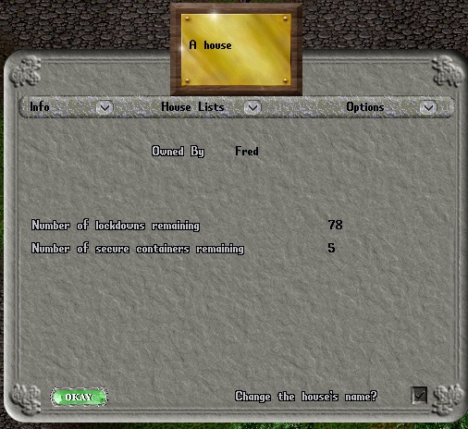

You can see from the sign that this house is owned by Fred. He never changed the house name. So it has the default name “A house” as the house name. You can see the number of lockdowns and secure containers available. Also, notice the buttons next to Info, House Lists and Options. Info will return you to the main sign gump you’re looking at. House Lists will bring up a gump that gives you access to three special lists you can add players to. Options will bring up a gump that will allow you to change the locks on your doors.

If you click on the House Lists button you will see the following gump.
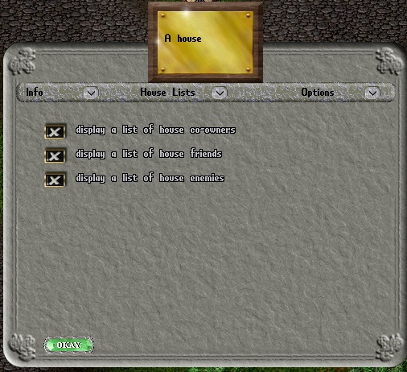

There are three lists that are associated with your house. They are house co-owners, house friends and house enemies. To access those lists you click on the button next to the list which will bring up a gump showing a list of characters that you have added to the list. In the next section we will look at the three lists,

A look at the house lists.

Click on the button next to “display a list of house co-owners” and you will see this gump.
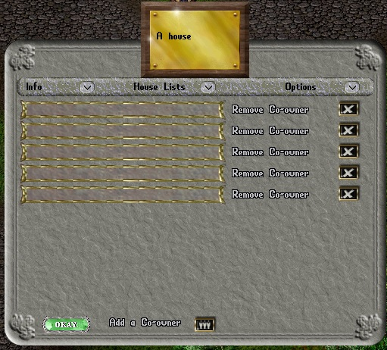

Currently Fred has no co-owners on his list. You can add a co-owner to your list by clicking the “Add co-owner” button at the bottom of the list. If you have a co-owner you wish to remove from the list, simply click the X by the co-owner’s name. Please note that the co-owner is removed instantly. If you mistakenly remove the wrong co-owner, that is easily corrected by adding the person again. As you can see, you can have a maximum of five co-owners.

Click on the House Lists button at the top of the gump. Then click on the “display a list of house friends.
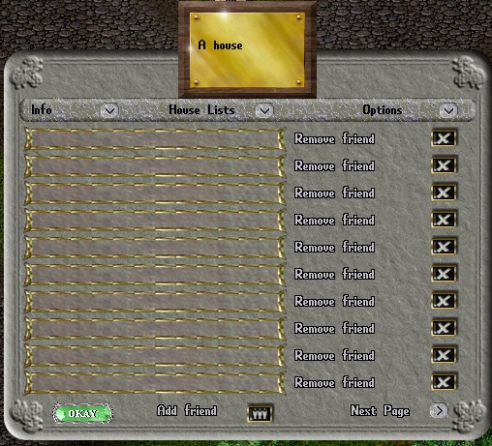

The friends list functions the same as the
co-owner list. I will not cover the add friend and remove friend functions as they are identical to the co-owner list. However, you can have as many as twenty friends associated with your house. There is a “Next Page” button in the lower right of the gump which will display a second page of friends.

In this document I may refer to the owner, any co-owners and friends of the house as house affiliates when speaking of them as a collective.

Now a brief look at the house enemies list. Click on the House Lists button at the top of the gump and click on the “display a list of house enemies” button.
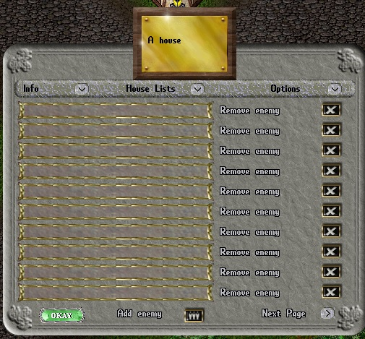

As you can see, it is similar to the friends list except this list is used to add an enemy to your house. Enemies cannot enter your house. If they try to enter through a door, as soon as they cross the threshhold they will be teleported outside under the house sign. You can add an enemy from the sign or by use of a house command. I will cover house commands later. As with house friends you can add up to twenty players to the house enemies list.

The house options menu

Click on the Options button. There are two things you can do from the house options menu, change the exterior door locks and change the interior door locks.
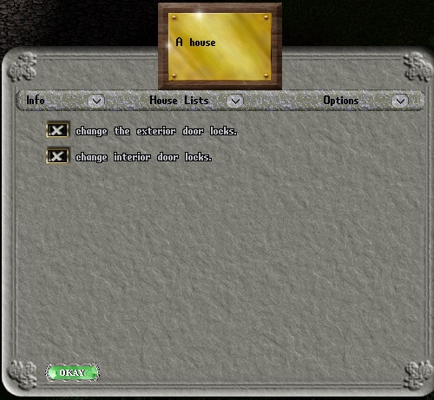

From the Options menu you can re-key the exterior doors and also re-key the interior doors, if any. Remember, that when you initially buy a house, any interior doors are not locked and cannot be locked until you “re-key” them. Before using either of these options you must have a “blank”, new, key. When you click on one of the buttons you will be prompted to target a key. After targeting the key, the appropriate doors will be keyed to that key.

House speech commands

There are quite a few speech commands that your house will respond to. If you are within your house boundaries and say these commands, your house will hear them and respond accordingly. These commands will allow you to lock things down so that they will not decay, create secure containers and other useful functions.

Here is the list of commands with an explanation of their function:

I wish to lock this down – Saying this command will give you a targeting cursor. Click on the item you want to lock down and it will not be movable. This prevents the system decay sweep from destroying the item during the decay cycle. This command is available to the owner and co-owners.

I wish to release this – This will release any item that was locked down using the previous command. You will receive a targeting cursor. Click on the item you wish to release. This command is available to the owner and co-owners.

I wish to secure this <affiliate level> – This allows you to secure a container, eg. a chest, crate etc., that can only be opened by anyone at the affiliate level you entered. You will receive a targeting cursor. Click on the item you wish to secure. If you fail to enter an affiliate level a GUMP will open to allow you to select an affiliate level. This command is available to the owner and co-owners.

I wish to unsecure this – This allows you to unsecure a container that was previously secured. You will receive a targeting cursor. Click on the item you wish to unsecure. A secure container can only be unsecured by a player at the same affiliate level as the player who secured it. Example: A co-owner cannot unsecure a container secured by the owner. The only exception is owners can unsecure all secure containers. This command is available to the owner and co-owners.

Remove thyself – With this command you can evict someone from the house. This does not ban the character. This command is available to the owner, co-owners and friends.

I ban thee – This command will evict a character from the house and add that character to the house enemies list. Thus preventing them from entering the house. This command is available to the owner and co-owners.

Reveal thyself – This command will reveal any hidden characters in the house. This command is available to the owner, co-owners and friends.

Am I in the house – This command will tell you if you are in the boundaries of the deeded house. Occasionally some shard developers will allocate extra exterior space when plotting the house boundaries. For example one square around the exterior of the house, or the “yard” area on some non-rectangular houses. Use this command to ascertain whether you are within the bounds of the deeded area. Actually, this was added for debugging purposes during the development of the static housing system and I left it in for players. This command is available to anyone who happens to be in a house’s boundary.

Visiting your house keeps it from decaying

House decay is part of the static housing system. In an effort to return abandoned houses to the market, house decay was conceived. House decay does not mean parts of your house will start crumbling away. It means that if you do not visit your house in a certain amount of time since the last time you visited it, it will revert to a “new house” available for purchase by another player. All items you placed in the house will be lost. The decay time is set by the shard’s admin. Consult the shard’s staff to find out what the decay time is. You can prevent your house from decaying by either you, the owner, or a co-owner using the house sign or by entering the house. When you use the sign you will receive a message telling you your house has been refreshed. If you enter your house it will also be refreshed but you will not receive a message. I did not want you to be receiving too many messages just for entering and leaving your home.

Selling a Static House

If you decide to sell your house to another player, you will sell it the same way you would sell anything. You drop the deed on the player which will open the secure trade GUMP. The player buying the house drops the proper amount of gold into the secure trade GUMP. Then you complete the transaction.

